Elton, Gruber, Brown, and Goetzmann
Modern Portfolio Theory and Investment Analysis, 9th Edition
Solutions to Text Problems: Chapter 5

Chapter 5: Problem 1

From Problem 1 of Chapter 4, we know that:

₁ = 12% ₂ = 6% ₃ = 14% ₄ = 12%

σ²₁ = 8 σ²₂ = 2 σ²₃ = 18 σ²₄ = 10.7

σ ₁ = 2.83% σ ₂ = 1.41% σ ₃ = 4.24% σ ₄ = 3.27%

σ ₁₂ = − 4 σ ₁₃ = 12 σ ₁₄ = 0 σ ₂₃ = − 6 σ ₂₄ = 0 σ ₃₄ = 0

ρ ₁₂ = − 1 ρ ₁₃ = 1 ρ ₁₄ = 0 ρ ₂₃ = − 1.0 ρ ₂₄ = 0 ρ ₃₄ = 0

In this problem, we will examine 2-asset portfolios consisting of the following pairs of securities:

Pair Securities

A 1 and 2
B 1 and 3
C 1 and 4
D 2 and 3
E 2 and 4
F 3 and 4

A. Short Selling Not Allowed
(Note that the answers to part A.4 are integrated with the answers to parts A.1,
A.2 and A.3 below.)

A.1
We want to find the weights, the standard deviation and the expected return of the minimum-risk porfolio, also known as the global minimum variance (GMV) portfolio, of a pair of assets when short sales are not allowed.

We further know that the compostion of the GMV portfolio of any two assets i and j is:

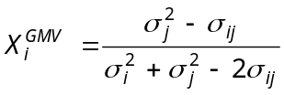

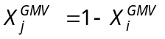

Pair A (assets 1 and 2):

Applying the above GMV weight formula to Pair A yields the following weights:

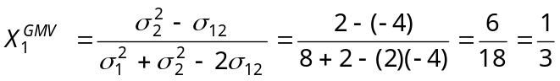 (or 33.33%)

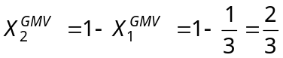 (or 66.67%)

This in turn gives the following for the GMV portfolio of Pair A:

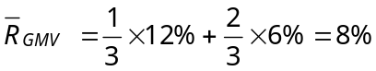

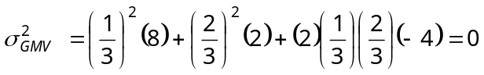

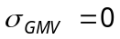

Recalling that ρ ₁₂ = − 1, the above result demonstrates the fact that, when two assets are perfectly negatively correlated, the minimum-risk portfolio of those two assets will have zero risk.

Pair B (assets 1 and 3):

Applying the above GMV weight formula to Pair B yields the following weights:

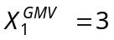 (300%) and 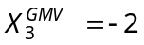 (−200%)

This means that the GMV portfolio of assets 1 and 3 involves short selling asset 3. But if short sales are not allowed, as is the case in this part of Problem 1, then the GMV “portfolio” involves placing all of your funds in the lower risk security (asset 1) and none in the higher risk security (asset 3). This is obvious since, because the correlation between assets 1 and 3 is +1.0, portfolio risk is simply a linear combination of the risks of the two assets, and the lowest value that can be obtained is the risk of asset 1.

Thus, when short sales are not allowed, we have for Pair B:

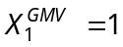 (100%) and 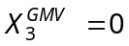 (0%)

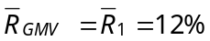; 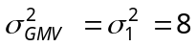; 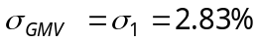

For the GMV portfolios of the remaining pairs above we have:
Pair 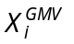 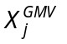 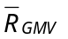 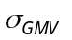

C (i = 1, j = 4) 0.572 0.428 12% 2.14%

D (i = 2, j = 3) 0.75 0.25 8% 0%

E (i = 2, j = 4) 0.8425 0.1575 6.95% 1.3%

F (i = 3, j = 4) 0.3728 0.6272 12.75% 2.59%

A.2 and A.3

For each of the above pairs of securities, the graph of all possible combinations (portfolios) of the securities (the portfolio possibilties curves) and the efficient set of those portfolios appear as follows when short sales are not allowed:

Pair A

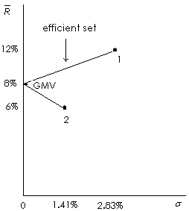

The efficient set is the positively sloped line segment.

Pair B

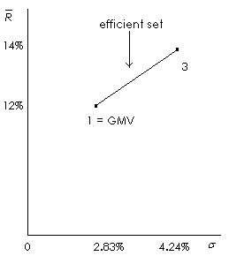

The entire line is the efficient set.

Pair C

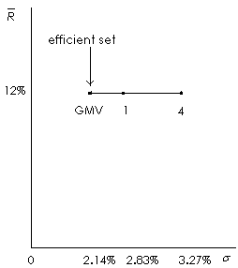

Only the GMV portfolio is efficient.

Pair D

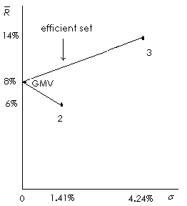

The efficient set is the positively sloped line segment.

Pair E

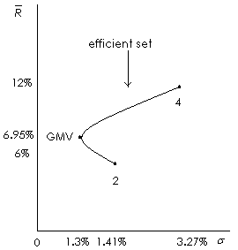

The efficient set is the positively sloped part of the curve, starting at the GMV portfolio and ending at security 4.

Pair F
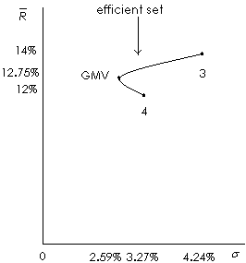

The efficient set is the positively sloped part of the curve, starting at the GMV portfolio and ending at security 3.

B. Short Selling Allowed

(Note that the answers to part B.4 are integrated with the answers to parts B.1, B.2 and B.3 below.)

B.1

When short selling is allowed, all of the GMV portfolios shown in Part A.1 above are the same except the one for Pair B (assets 1 and 3). In the no-short-sales case in Part A.1, the GMV “portfolio” for Pair B was the lower risk asset 1 alone. However, applying the GMV weight formula to Pair B yielded the following weights:
(300%) and (−200%)

This means that the GMV portfolio of assets 1 and 3 involves short selling asset 3 in an amount equal to twice the investor’s original wealth and then placing the original wealth plus the proceeds from the short sale into asset 1. This yields the following for Pair B when short sales are allowed:
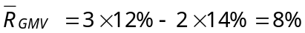

Recalling that ρ ₁₃ = +1, this demonstrates the fact that, when two assets are perfectly positively correlated and short sales are allowed, the GMV portfolio of those two assets will have zero risk.

B.2 and B.3

When short selling is allowed, the portfolio possibilities graphs are extended.

Pair A

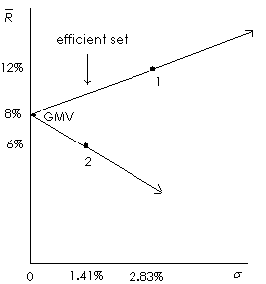

The efficient set is the positively sloped line segment through security 1 and out toward infinity.

Pair B

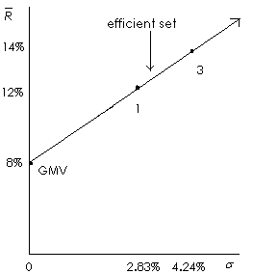

The entire line out toward infinity is the efficient set.

Pair C

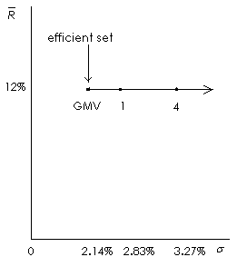

Only the GMV portfolio is efficient.

Pair D

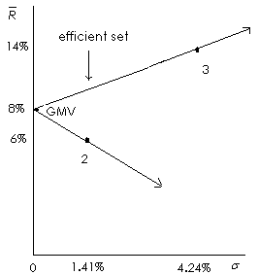

The efficient set is the positively sloped line segment through security 3 and out toward infinity.

Pair E

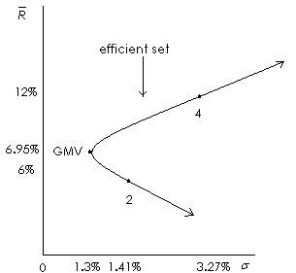

The efficient set is the positively sloped part of the curve, starting at the GMV portfolio and extending past security 4 toward infinity.

Pair F

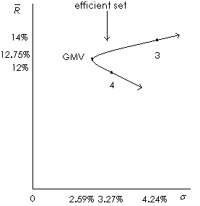

The efficient set is the positively sloped part of the curve, starting at the GMV portfolio and extending past security 3 toward infinity.

C.

Pair A (assets 1 and 2):

Since the GMV portfolio of assets 1 and 2 has an expected return of 8% and a risk of 0%, then, if riskless borrowing and lending at 5% existed, one would borrow an infinite amount of money at 5% and place it in the GMV portfolio. This would be pure arbitrage (zero risk, zero net investment and positive return of 3%). With an 8% riskless lending and borrowing rate, one would hold the same portfolio one would hold without riskless lending and borrowing. (The particular portfolio held would be on the efficient frontier and would depend on the investor’s degree of risk aversion.)

Pair B (assets 1 and 3):

Since short sales are allowed in Part C and since we saw in Part B that when short sales are allowed the GMV portfolio of assets 1 and 3 has an expected return of 8% and a risk of 0%, the answer is the same as that above for Pair A.

Pair C (assets 1 and 4):

We have seen that, regardless of the availability of short sales, the efficient frontier for this pair of assets was a single point representing the GMV portfolio, with a return of 12%. With riskless lending and borrowing at either 5% or 8%, the new efficient frontier (efficient set) will be a straight line extending from the vertical axis at the riskless rate and through the GMV portfolio and out to infinity. The amount that is invested in the GMV portfolio and the amount that is borrowed or lent will depend on the investor’s degree of risk aversion.

Pair D (assets 2 and 3):

Since assets 2 and 3 are perfectly negatively correlated and have a GMV portfolio with an expected return of 8% and a risk of 0%, the answer is identical to that above for Pair A.

Pair E (assets 2 and 4):

We arrived at the following answer graphically; the analytical solution to this problem is presented in the subsequent chapter (Chapter 6). With a riskless rate of 5%, the new efficient frontier (efficient set) will be a straight line extending from the vertical axis at the riskless rate, passing through the portfolio where the line is tangent to the upper half of the original portfolio possibilities curve, and then out to infinity. The amount that is invested in the tangent portfolio and the amount that is borrowed or lent will depend on the investor’s degree of risk aversion. The tangent portfolio has an expected return of 9.4% and a standard deviation of 1.95%. With a riskless rate of 8%, the point of tangency occurs at infinity.

Pair F (assets 3 and 4):

We arrived at the following answer graphically; the analytical solution to this problem is presented in the subsequent chapter (Chapter 6). With a riskless rate of 5%, the new efficient frontier (efficient set) will be a straight line extending from the vertical axis at the riskless rate, passing through the portfolio where the line is tangent to the upper half of the original portfolio possibilities curve, and then out to infinity. The amount that is invested in the tangent portfolio and the amount that is borrowed or lent will depend on the investor’s degree of risk aversion. The tangent (optimal) portfolio has an expected return of 12.87% and a standard deviation of 2.61%. With a riskless rate of 8%, the new efficient frontier will be a straight line extending from the vertical axis at the riskless rate, passing through the portfolio where the line is tangent to the upper half of the original portfolio possibilities curve, and then out to infinity. The tangent (optimal) portfolio has an expected return of 12.94% and a standard deviation of 2.64%.

Chapter 5: Problem 2

From Problem 2 of Chapter 4, we know that:

_{A} = 1.22% _{B} = 2.95% _{C} = 7.92%

σ²_{A} = 15.34 σ²_{B} = 14.42 σ²_{C} = 46.02

σ _{A} = 3.92% σ _{B} = 3.8% σ _{C} = 6.78%

σ _{AB} = 2.17 σ _{AC} = 7.24 σ _{BC} = −19.89

ρ _{AB} = 0.15 ρ _{AC} = 0.27 ρ _{BC} = −0.77

In this problem, we will examine 2-asset portfolios consisting of the following pairs of securities:

Pair Securities
1 A and B
2 A and C
3 B and C

A. Short Selling Not Allowed

(Note that the answers to part A.4 are integrated with the answers to parts A.1,
A.2 and A.3 below.)

A.1

We want to find the weights, the standard deviation and the expected return of the minimum-risk porfolio, also known as the global minimum variance (GMV) portfolio, of a pair of assets when short sales are not allowed.

We further know that the compostion of the GMV portfolio of any two assets i and j is:

Pair 1 (assets A and B):

Applying the above GMV weight formula to Pair 1 yields the following weights:

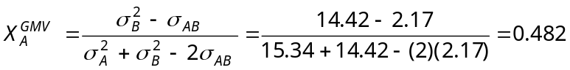 (or 48.2%)

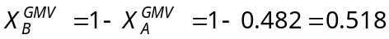 (or 51.8%)

This in turn gives the following for the GMV portfolio of Pair 1:

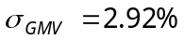

For the GMV portfolios of the remaining pairs above we have:

Pair

2 (i = A, j = C) 0.827 0.173 2.38% 3.73%

3 (i = B, j = C) 0.658 0.342 4.65% 1.63%

A.2 and A.3

For each of the above pairs of securities, the graph of all possible combinations (portfolios) of the securities (the portfolio possibilties curves) and the efficient set of those portfolios appear as follows when short sales are not allowed:

Pair 1
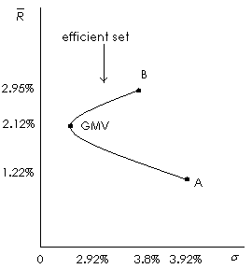

The efficient set is the positively sloped part of the curve, starting at the GMV portfolio and ending at security B.

Pair 2
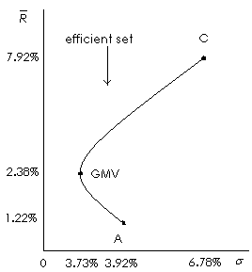

The efficient set is the positively sloped part of the curve, starting at the GMV portfolio and ending at security C.

Pair 3
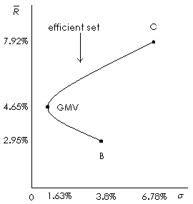

The efficient set is the positively sloped part of the curve, starting at the GMV portfolio and ending at security C.

B. Short Selling Not Allowed

(Note that the answers to part B.4 are integrated with the answers to parts B.1,
B.2 and B.3 below.)

B.1

When short selling is allowed, all of the GMV portfolios shown in Part A.1 above remain the same.

B.2 and B.3

When short selling is allowed, the portfolio possibilities graphs are extended.

Pair 1

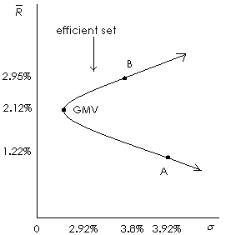

The efficient set is the positively sloped part of the curve, starting at the GMV portfolio and extending past security B toward infinity.

Pair 2

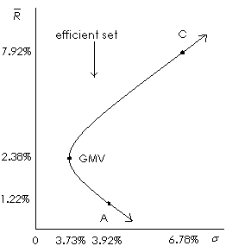

The efficient set is the positively sloped part of the curve, starting at the GMV portfolio and extending past security C toward infinity.

Pair 3

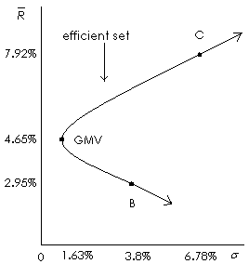

The efficient set is the positively sloped part of the curve, starting at the GMV portfolio and extending past security C toward infinity.

C.

In all cases where the riskless rate of either 5% or 8% is higher than the returns on both of the individual securities, if short sales are not allowed, any rational investor would only invest in the riskless asset. Even if short selling is allowed, the point of tangency of a line connecting the riskless asset to the original portfolio possibilities curve occurs at infinity for all cases, since the original GMV portfolio’s return is lower than 5% in all cases.

Chapter 5: Problem 3

The answers to this problem are given in the answers to part A.1 of Problem 2.

Chapter 5: Problem 4

The locations, in expected return standard deviation space, of all portfolios composed entirely of two securities that are perfectly negatively correlated (say, security C and security S) are described by the equations for two straight lines, one with a positive slope and one with a negative slope. To derive those equations, start with the expressions for a two-asset portfolio's standard deviation when the two assets' correlation is −1 (the equations in (5.8) in the text), and solve for X_{C} (the investment weight for security C). E.g., for the first equation:
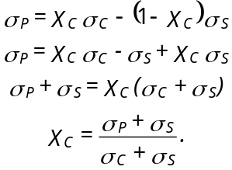

Now plug the above expression for X_{C} into the expression for a two-asset portfolio's expected return and simplify:
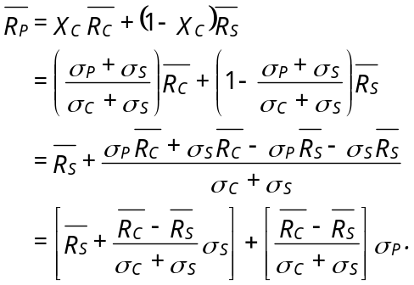

The above equation is that of a straight line in expected return standard deviation space, with an intercept equal to the first term in brackets and a slope equal to the second term in brackets.

Solving for X_{C} in the second equation in (5.8) gives:
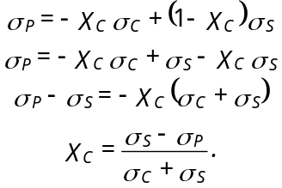

Substitute the above expression for X_{C} into the equation for expected return and simplify:

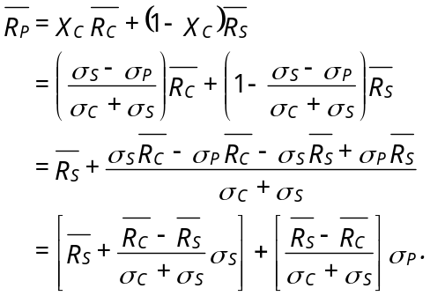

The above equation is also that of a straight line in expected return standard deviation space, with an intercept equal to the first term in brackets and a slope equal to the second term in brackets. The intercept term for the above equation is identical to the intercept term for the first derived equation. The slope term is equal to −1 times the slope term of the first derived equation. So when one equation has a positive slope, the other equation has a negative slope (when the expected returns of the two assets are equal, the two lines are coincident), and both lines meet at the same intercept.

Chapter 5: Problem 5

When ρ equals 1, the least risky "combination" of securities 1 and 2 is security 2 held alone (assuming no short sales). This requires X₁ = 0 and X₂ = 1, where the X's are the investment weights. The standard deviation of this "combination" is equal to the standard deviation of security 2; σ_{P} = σ₂ = 2.

When ρ equals -1, we saw in Chapter 5 that we can always find a combination of the two securities that will completely eliminate risk, and we saw that this combination can be found by solving X₁ = σ₂/(σ₁ + σ₂). So, X₁ = 2/(5 + 2) = 2/7, and since the investment weights must sum to 1, X₂ = 1 - X₁ = 1 - 2/7 = 5/7. So a combination of 2/7 invested in security 1 and 5/7 invested in security 2 will completely eliminate risk when ρ equals -1, and σ_{P} will equal 0.

When ρ equals 0, we saw in Chapter 5 that the minimum-risk combination of two assets can be found by solving X₁ = σ₂²/(σ₁² + σ₂²). So, X₁ = 4/(25 + 4) = 4/29, and X₂ = 1 - X₁ = 1 - 4/29 = 25/29. When ρ equals 0, the expression for the standard deviation of a two-asset portfolio is

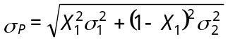

Substituting 4/29 for X₁ in the above equation, we have

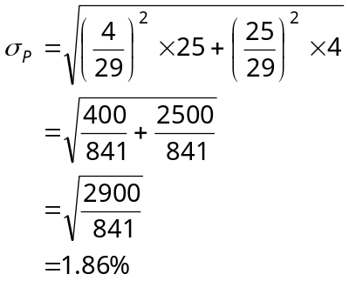

Chapter 5: Problem 6

If the riskless rate is 10%, then the risk-free asset dominates both risky assets in terms of risk and return, since it offers as much or higher expected return than either risky asset does, for zero risk. Assuming the investor prefers more to less and is risk averse, the optimal investment is the risk-free asset.

